Carers Panel Meeting Note 25th September 2025
Topic | Notes
Welcome coffees and short introduction from Gemma on background of panel | Gemma shared some practicalities, purpose of panel and some recent priorities.  Short intros from group members.
Matters arising | GP Pack – updating on progress during meeting.  Future planning group – not addressed at this meeting. Move to next agenda.
CEO introduction with time for questions from the panel | Jenny White new CEO CoEL introduced self and took some questions from panel.
Introducing David Binnie as local carer rep? | Introduced David to the group : Carers Representative for the IJB for East Lothian HSCP. David’s role is to ensure that the views and interests of unpaid carers are taken into account by the IJB, which is responsible for planning, resourcing and overseeing the delivery of integrated health and social care services in East Lothian. He works closely with other IJB members, HSCP staff and partner organisations to promote and improve the support available for carers.
IJB consultation | East Lothian's Integration Joint Board (IJB) is developing its Strategic Plan for 2025-2030.  Consultation is open currently and feedback deadline is 31st October 2025.  Jenny and Gemma will be constructing an organisational response to the consultation. Introduced IJB strategy and significance of this for carers. Asked group how they might like to engage – suggested members can individually respond as well as offering an opportunity to compile a group response. Gemma offered to schedule date. This has since been scheduled for 23.10.25 on teams.
Update on GP practice resource pack | Offered feedback opportunity and several members had looked over the pack and had some suggestions. Agreed action to set up review group. LD, KH, NC and SW to meet, review and feedback to the rest of the group. DB added to this group after panel in order to ensure 2 members who had seen project through since the start were participating.
Think Carer update – North Berwick | Hilary shared some feedback about recent Think Carer at North Berwick Practice.
Survey and exercise to invite members to share some of their priorities | Members were asked to work together in partners and discuss responses to the following questions.  - What has motivated you to get involved with the Carers Panel ?  - What issues or challenges faced by unpaid carers matter most to you right now?  - If the Carers Panel could achieve just one thing in the next year, what would you like it to be?  - What would make participation in this group meaningful for you?  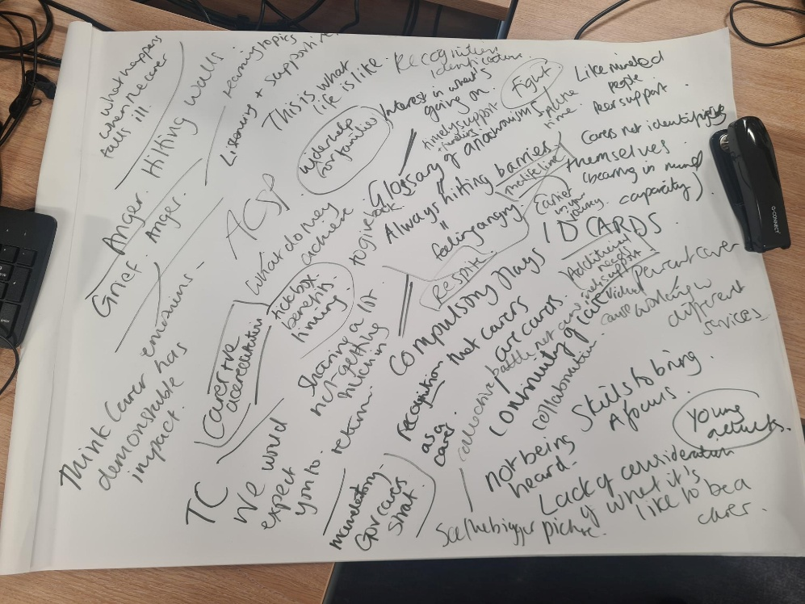  Notes included. To be collated and used to plan at a future panel meeting to decide next priorities and project work.

Background of the panel
Carers Panel has been running since 2021. We have founding members here today.
The panel was set up to strengthen the collective voice of carers in East Lothian. Membership is open to people who are currently in an unpaid caring role and former carers with an interest in improving the lives of carers.
The focus of the Carers panel is to discuss potential solutions to common problems for carers. The panel are also encouraged to be involved in consultations that impact carers and the people that they care for.
We are always keen to increase their membership to ensure the panel can represent the views of carers from a variety of different caring situations.
Recent projects for the carers panel have included:
- Campaigning for a carer ID card
- Campaigning around Carers Week and supporting local organisations to contribute and collaborate on the week
- Commenting on the local carers strategy - The local strategy officer reports to the panel annually
- Offering a lived experience perspective to an Occupational Therapy student carer awareness training
- Speaking about the impact of good support for carers at a dementia carer education session
- Developing a resource pack for GP practices in East Lothian to support them to become more carer aware

Panel Volunteer
GT asked whether anyone might be interested in being a panel volunteer to help with set up of panel.
NHS Education for Scotland – not discussed – follow up after meeting.
CoEL AGM – Wednesday 29th October. Date provided and follow up after meeting.
Carers Parliament - 30th Oct – Date provided and follow up after meeting.
Carers Rights Day – 20th Nov – Date provided and follow up after meeting.

