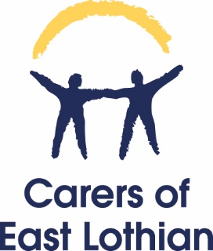
Carers Panel Meeting Report 25th June 2026
Topic | Notes
Matters Arising | Right to Breaks Consultation  Thank you to those of you who attended the April Carers Panel Meeting and input into the discussion around the government consultation on the right to breaks. Carers of East Lothian submitted an organisational response to the governments right to breaks consultation and we incorporated anonymous information from the discussion into our response. We also collected views from the staff team based on their work with carers and fed these into our response.  Carers Centre Managers completed a collective response to the consultation. We understand that the consultation received roughly 400 responses and a consultation analysis report will now be produced. Following this, regulations will be drawn up. I will share further updates with the panel when I have them.  CoEL strategy  Thank you to those of you who attended the session on the CoEL strategy development in May. Anyone who is not already done so can complete our short survey of views here: Carers Panel and Volunteer Strategy Development Session - follow up questionnaire – Fill in form
Jenny’s report | Please see report attached to email. If you have any questions on the report, please email me gemma@coel.org.uk
GP Practice Work | I would like us to discuss next steps in August.
Strategy Development | We will be hosting an in-person session in August for carers to feed into our strategy development work. Provisional date afternoon of 18th August, but this could change. I’d love for some of you to come. I will update you as soon as this is confirmed.
Right to Breaks/ Carers Rights Day | At the policy and engagement meeting with Coalition of Carers in Scotlan d on Monday this week, they raised the possibility of carers centres using Carers Rights Day (November 19th) as an opportunity to engage with local MSP’s around Right To Breaks. By this point, there may be updates on regulations that could be discussed. I hoped to get your views today on our approach to this. We can discuss at the August meeting.
Fringe by the Sea | We will be holding a stall in the Encounter Space at Fringe by the Sea on 3rd August 2026 to raise awareness of our organisation and support for carers.
Parking Charges | Please note, we will be asking carers in our North Berwick support group if anyone is affected by parking charge introductions in the area and plan to keep the feedback and share via appropriate channels if we see patterns.
IMPACT project | Hilary Smyth who was previously our Volunteer and Training Coordinator is working with us on a project called IMPACT. The focus of the piece of work will be to explore what can be done in communities to support carers more effectively. The project will focus on the North Berwick Coastal Area. There will be a commitment of 4 focus groups. She is looking for carers to participate in this. Carers will be financially remunerated for their involvement but must live in the area the project covers, or local to it and have a good knowledge of services and support available in the North Berwick coastal area. If you are interested in hearing more, please let me know.
In Control Scotland | Please see my previous email with details of two projects with In Control Scotland that carers can get involved in.
Next meeting | 13th August 2026. Lammemuir Room, East Lothian Community Hospital

